**Task: *Testing the ‘Order Details page***

|  |  |
| --- | --- |
| Test Case #: 2 | Test Case Name: Validate order details page |
| System: On the Spot (website) | System: Order |
| Designed by: Panama | Designed date: 20/04/2016 |
| Executed by: Bunny | Executed date: 27/06/2016 |
| Short Description: Test the validation for the “order details page.” | |

**Pre conditions:**

* User have an account or the user had created an account on the “On the Spot delivery” site
* User should measure the package in respect of their weight and size.

|  |  |  |  |  |
| --- | --- | --- | --- | --- |
| Step | Action | Expected System Response | Pass/ Fail | Comment |
| 1. | Entered the Suburb name of the destination address “Herston” | The system automatically comes up **(API geocode)** with the state, postcode and country name along with the suburb which is “Herston QLD 4006, Australia” | P | User- Friendly  This reduce the efforts of the user to type the whole address |
| 2. | Entered letters “ww” in the Contact number tab. | System shows the entered letters in red colour (because it is not valid) | P | This helps the customer to re-enter the digits instead of letters |
| 3. | Entered the weight of the package as 23 | System shows the entered value (in kg) in red colour (because the maximum weight set for the package is 22) | P | This helps the customer to make sure that that they parcel weigh no more than 22 kg. |
| 4. | Clicked the Submit button | Check through all the tabs. Looks whether the info is valid, any info is missing.  Navigate to the order confirmation page. | P | User can once again verify before submitting the order. |

**Pre conditions:**

* User has completed the order details (all valid) in correct format.
* User then able to the order confirmation page.

Below is the screenshot of the above mentioned testing

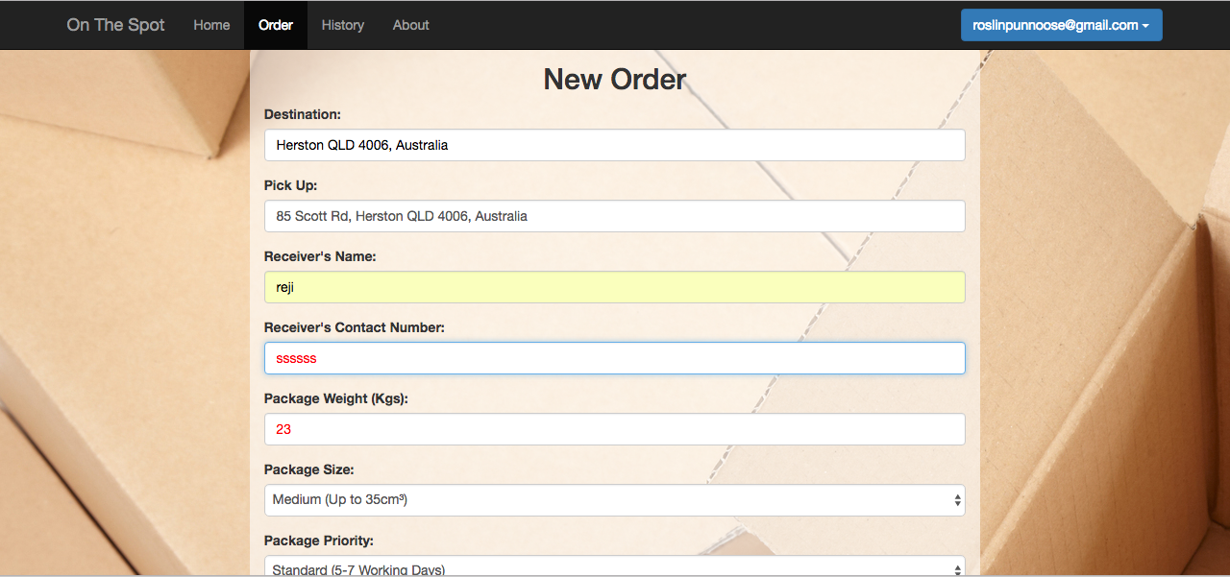



The beneficial for testing this is described in the portfolio document.